
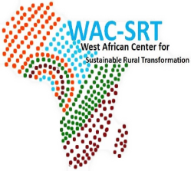
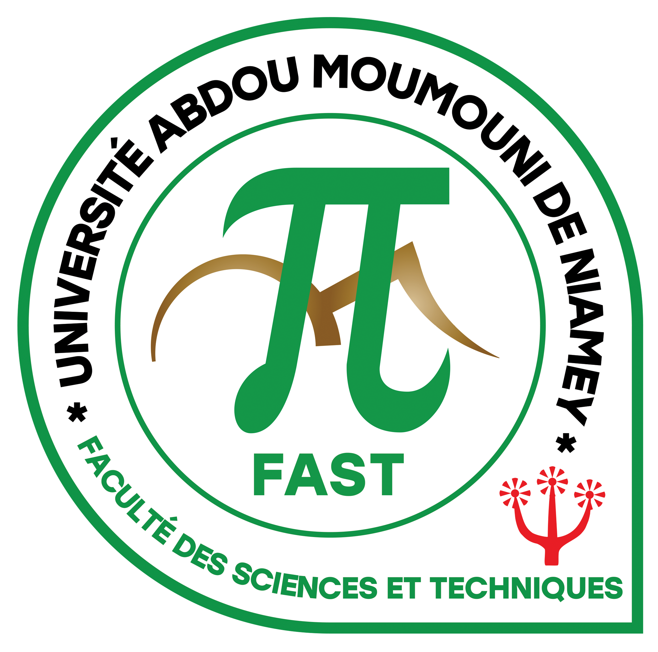

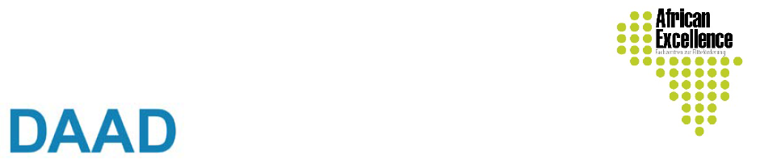



Eligible Countries: West Africa country

PHOTO

WAC-SRT
Application Form
Integrated Master PROGRAM for sustainable transformation of rural area Abdou Moumouni University of Niamey (Niger)

1. Personal data
Last Name (Family…………………………………………………………………………
First Name(s): ………………………………………………………………………………
Gender: Female …… ……Male
Date and place of birth: ……………/………/………../….(day /month/year)….
Nationality:…………………………………………………………………………………….
Marital status: ……………………………….. Children …………………………………..
Country of residence: ………………………………………………………………………
Permanent address : ………………………………………………………………………
Telephone number (compulsory): ………………………………………………………….
Email address (compulsory): ………………………………………………………………
P.O. Box:……………………………………………………………………………………
Person to contact in case of emergency Name: ………………………………………...….
Telephone number: ………………………………. Email address:……………………......

2. University Education
Universities attended | Dates of attendance | Qualification obtained | Date qualification obtained  Title of degree awarded and grade

3. Language skills
Please indicate using abbreviation L, I or A (L=Low; I=Intermediate; A=Advanced)
Notation  Languages | Reading |  |  | Writing |  |  | Speaking
Notation  Languages | L | I | A | L | I | A | L | M | A
English
French
Other
4. Computer skills
 | Word | Excel | Power Point | SPSS | Others (specify)
 |  |  |  |  | Statistics | GIS/Remote Sensing Package
Beginner
Intermediate
Advanced
5. Employment record (if Applicable)
Name and address of two previous employers (Please start with your most recent employment) | Dates of attendance | Position held

6. Letter of motivation
Personal statement should include the student’s academic and personal qualities as well as his/her interests in research in the area of rural transformation in West Africa.
7. Application supporting documents
- Completed application form;
- be a citizen of a west African country
- provide a birth certificate or other equivalent document
- have a certificate of nationality
- Birth certificate
- Provide a curriculum vitae
- Submit a letter of motivation
- Provide transcripts and copies of diploma
- Submit a detailed program of the training received
- Provide two references letters
- Research project
- Provide a copy of the receipt for application study fees 10,000 F CFA (15€). Application fees can be sent by NITA Transfer to the following address: Mr Hamidou Hama Harouna, Tel: +227 99 72 00 00 ; E-mail: hamidouhama73@gmail.com or By Wave Mobile Money, or Ecobank – Mobile Money Tel:+227 90754289
- Submit a letter of authorization from the employer (for people in employment)
8: Mode of financing of programme
Please tick (√) preferred choice of financing your programme
- SCHOLARSHIP
If not successful with scholarship, will you consider self-financing option?
SELF-FINANCING ☐ Yes ☐ No
Female candidates are encouraged to apply.
I confirm to the best of my knowledge that the information given in this form is true.
Date:…..../.........../............/ Signature:...............................................
Deadline for application January 24th, 2026.

Candidates may apply directly to the Master research program by sending all required information via E-mail to: wacsrt.uam@gmail.com
Please copy to : ikmassalatchi87@gmail.com or david.agbo@uam.edu.ne

Hard copies for Niger candidates can be deposited at Scolarité, Faculté des Sciences et Techniques (FAST).
Please copy to : ibraboub@yahoo.fr

