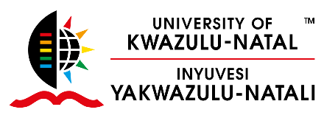
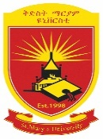
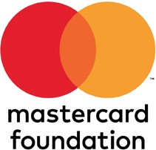
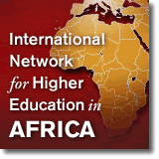
Call for Application for the Third HEFAALA Master Class Workshops
25-29 April 2022 | Addis Ababa | ETHIOPIA

Building Leadership of Young Academics: The Power of Academic Collaboration

African higher education has witnessed a phenomenal expansion in the last decade. This overwhelming growth has created huge opportunities for young Africans with relentless desire and aspirations to study in higher learning institutions.
Similarly, these institutions are also managed by an army of young academics who grapple with a multitude of challenges wrought about this massive growth. Many African academic institutions are staffed with young, over-committed and ambitious academics but they often lack a PhD, are short in language skills, weak in communication acumen, and poor leadership qualities, with a huge room for capacity building.
Little to no attention has been afforded to the induction of academics into the academic profession in Africa. Most academics are not well prepared for research; nor are they trained to teach; less so equipped with leadership and management skills.
The shifting professional interests, experiences and demands as regards African academics seem to have also direct implications on the academic processes from recruitment to promotion. Universities, however, have largely continued business as usual without due consideration of these developments including the need for systematic leadership development in academia.
As the need for advancing skills of African academics and researchers is mounting, efforts are underway to address it. The HEFAALA Masterclass is one such effort intended to provide a 5-day opportunity packed in a Conference, Symposium and Workshop.
The Masterclass features active and interactive engagements in key topical issues of higher education embedded in the Third Higher Education Forum for Africa, Asia and Latin America (HEFAALA) Symposium under a theme “Academic Collaboration in Africa, Asia and Latin America in the Post- COVID World” and the 20th International Conference on Private Higher Education in Africa under a theme “Embracing New Realities and Paradigms: Africa's Higher Education Response”.
In this Masterclass which is running under a theme “Building Leadership of Young Academics: The Power of Academic Collaboration” three events are taking place under the following themes:
- Masterclass I: Co-Constructing Knowledge: The Power of Collaboration
- Masterclass II: Knocking at the Gates of Knowledge Keepers: The Significance of Collaboration
- Masterclass III: Overcoming Marginality through Academic Collaboration
The programme, intended to advance the next generation academics, scholars and researchers, promises resourcing academics, experts and practitioners, both seasoned and emerging, to deliver rich lectures and seminars punctuated with case studies, group discussions and group activities.
This Masterclass workshop, a sponsored opportunity limited to those 35 years old and under, is very competitive and is only provided to 25 Africans. The workshop, which is funded by Mastercard Foundation and organized by the International Network for Higher Education in Africa (South Africa) and Saint Mary’s University (Ethiopia) is running from 25 to 29 April 2022 in Addis Ababa along with the Third International Conference and the 20th International Conference. More information on the Conference and Symposium are provided here.
The sponsored opportunity targets doctoral candidates and recent PhD graduates (in the last two years) who work/study in African academic and research organizations/institutions.
The sponsored opportunity covers air fare, accommodation, visa fees, Covid-19 tests, travel insurance, and meals, among others.
If interested and meet the criteria, please complete this form and send it with resume/cv and a copy of your passport to Dr. Ayenachew Woldegiyorgis at woldegiy@bc.edu in a copy to teferra@bc.edu.

